BÁO CÁO THỰC HÀNH
IT3280 – 147793 – THỰC HÀNH KIẾN TRÚC MÁY TÍNH
Tuần 10:
Họ và tên | Lê Đồng Cảnh Phú
Mã số sinh viên | 20225755

Assignment 1
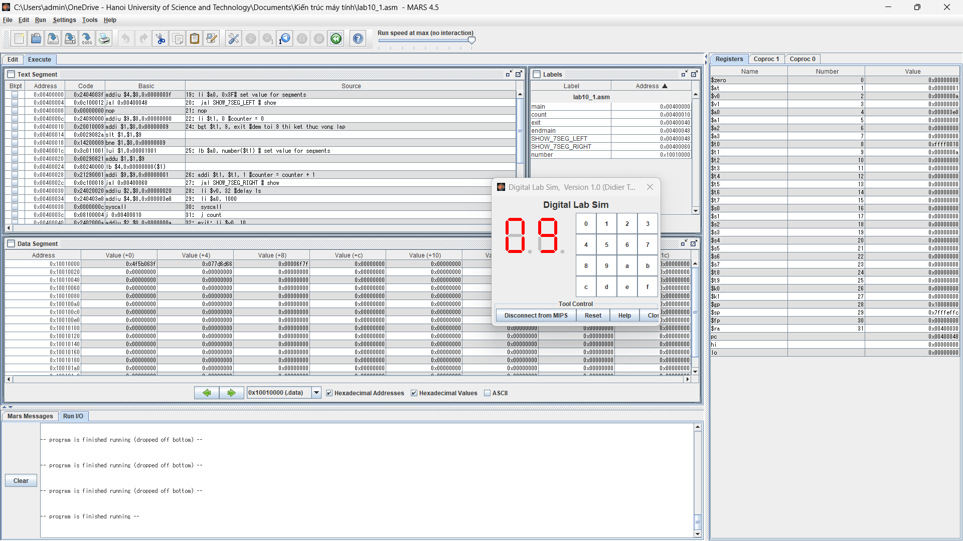
#1: 00000110 0x06
#2: 01011011 0x5B
#3: 01001111 0x4F
#4: 01100110 0x66
#5: 01101101 0x6D
#6: 01111101 0x7D
#7: 00000111 0x07
#8: 01111111 0x7F
#9: 01101111 0x6F
.data
number: .byte 0x3F 0x06 0x5B 0x4F 0x66 0x6D 0x7D 0x07 0x7F 0x6F #Tao mang cac so tu 0 -> 9
.eqv SEVENSEG_LEFT 0xFFFF0011 # Dia chi cua den led 7 doan trai.
# Bit 0 = doan a;
# Bit 1 = doan b; ...
# Bit 7 = dau .
.eqv SEVENSEG_RIGHT 0xFFFF0010 # Dia chi cua den led 7 doan phai
.text
main:
li $a0, 0x3F# set value for segments
jal SHOW_7SEG_LEFT # show
nop
li $t1, 0 #counter = 0
count:
bgt $t1, 9, exit #dem toi 9 thi ket thuc vong lap
lb $a0, number($t1) # set value for segments
addi $t1, $t1, 1 #counter = counter + 1
jal SHOW_7SEG_RIGHT # show
li $v0, 32 #delay 1s
li $a0, 1000
syscall
j count
exit: li $v0, 10
syscall
endmain:
#---------------------------------------------------------------
# Function SHOW_7SEG_LEFT : turn on/off the 7seg
# param[in] $a0 value to shown
# remark $t0 changed
#---------------------------------------------------------------
SHOW_7SEG_LEFT: li $t0, SEVENSEG_LEFT # assign port's address
sb $a0, 0($t0) # assign new value
nop
jr $ra
nop
#---------------------------------------------------------------
# Function SHOW_7SEG_RIGHT : turn on/off the 7seg
# param[in] $a0 value to shown
# remark $t0 changed
#---------------------------------------------------------------
SHOW_7SEG_RIGHT: li $t0, SEVENSEG_RIGHT # assign port's address
sb $a0, 0($t0) # assign new value
nop
jr $ra
nop

Assignment 2
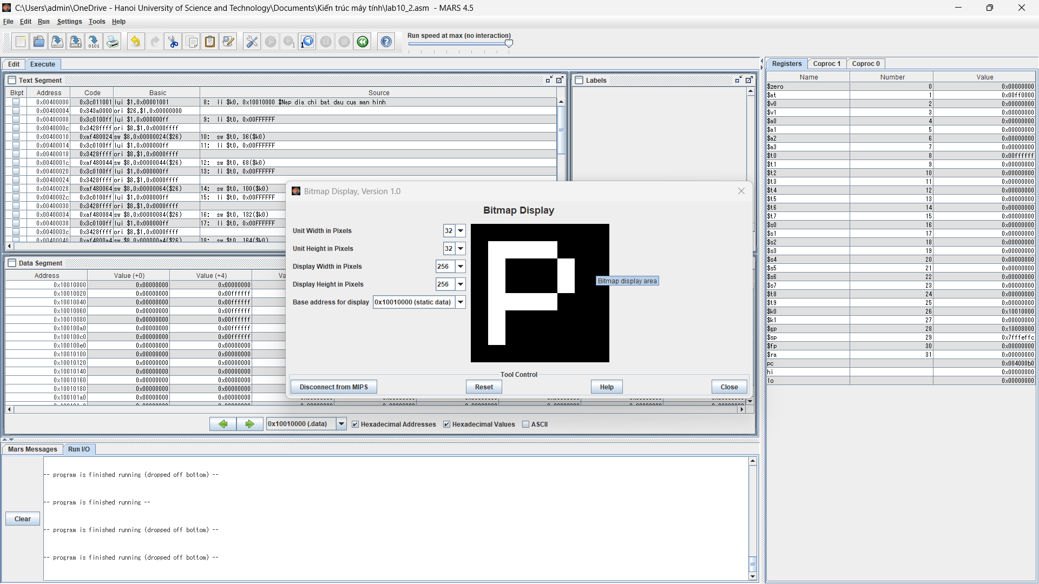
.eqv MONITOR_SCREEN 0x10010000 #Dia chi bat dau cua bo nho man hinh
.eqv RED 0x00FF0000 #Cac gia tri mau thuong su dung
.eqv GREEN 0x0000FF00
.eqv BLUE 0x000000FF
.eqv WHITE 0x00FFFFFF
.eqv YELLOW 0x00FFFF00
.text
li $k0, MONITOR_SCREEN #Nap dia chi bat dau cua man hinh
li $t0, WHITE
sw $t0, 36($k0)
li $t0, WHITE
sw $t0, 68($k0)
li $t0, WHITE
sw $t0, 100($k0)
li $t0, WHITE
sw $t0, 132($k0)
li $t0, WHITE
sw $t0, 164($k0)
li $t0, WHITE
sw $t0, 196($k0)
li $t0, WHITE
sw $t0, 40($k0)
li $t0, WHITE
sw $t0, 44($k0)
li $t0, WHITE
sw $t0, 48($k0)
li $t0, WHITE
sw $t0, 84($k0)
li $t0, WHITE
sw $t0, 116($k0)
li $t0, WHITE
sw $t0, 144($k0)
li $t0, WHITE
sw $t0, 140($k0)
li $t0, WHITE
sw $t0, 136($k0)

